
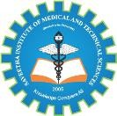
SIMATS ENGINEERING

Saveetha Institute of Medical and Technical Sciences Chennai- 602105
Student Name: N.SURYA Reg. No: 192511233
Course Code: CSA0917 Slot: C
Course Name: PROGRAMMING IN JAVA
Course Faculty: DR.P.VIJAYARAGAVAN
Project Title: A Computer Vision-Based Crop Disease Severity Assessment System

Module Photographs:
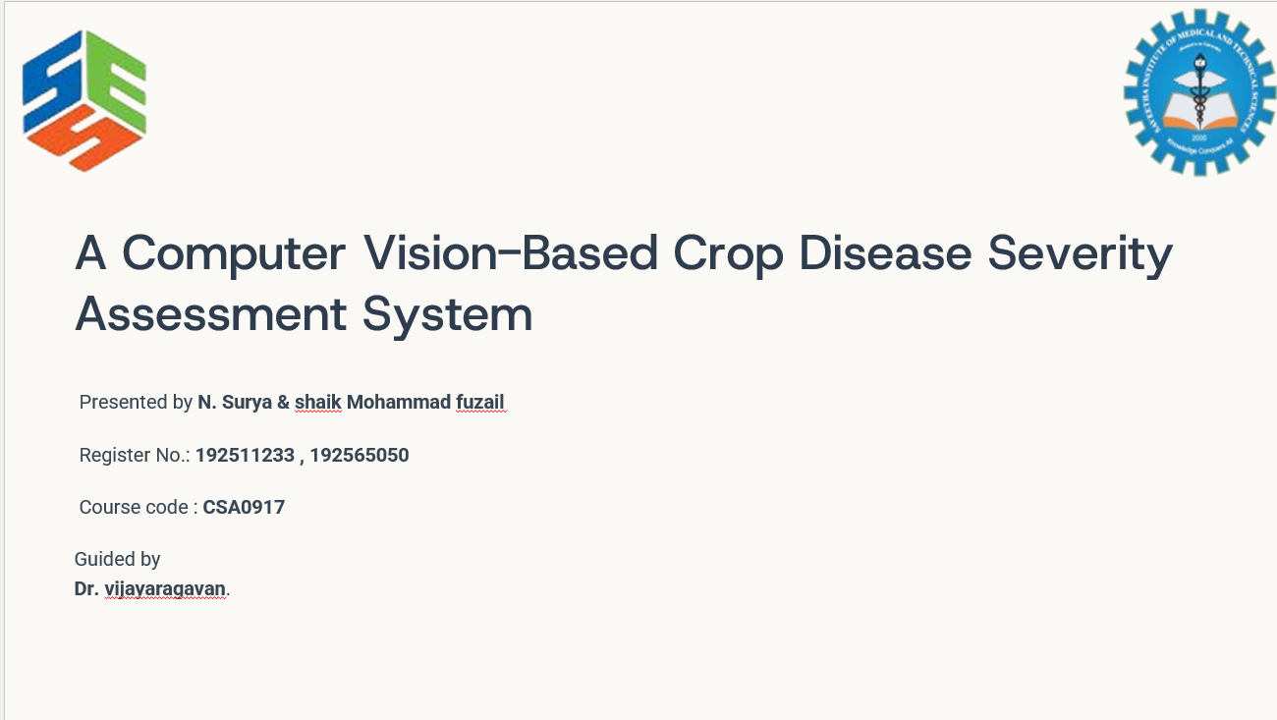 | 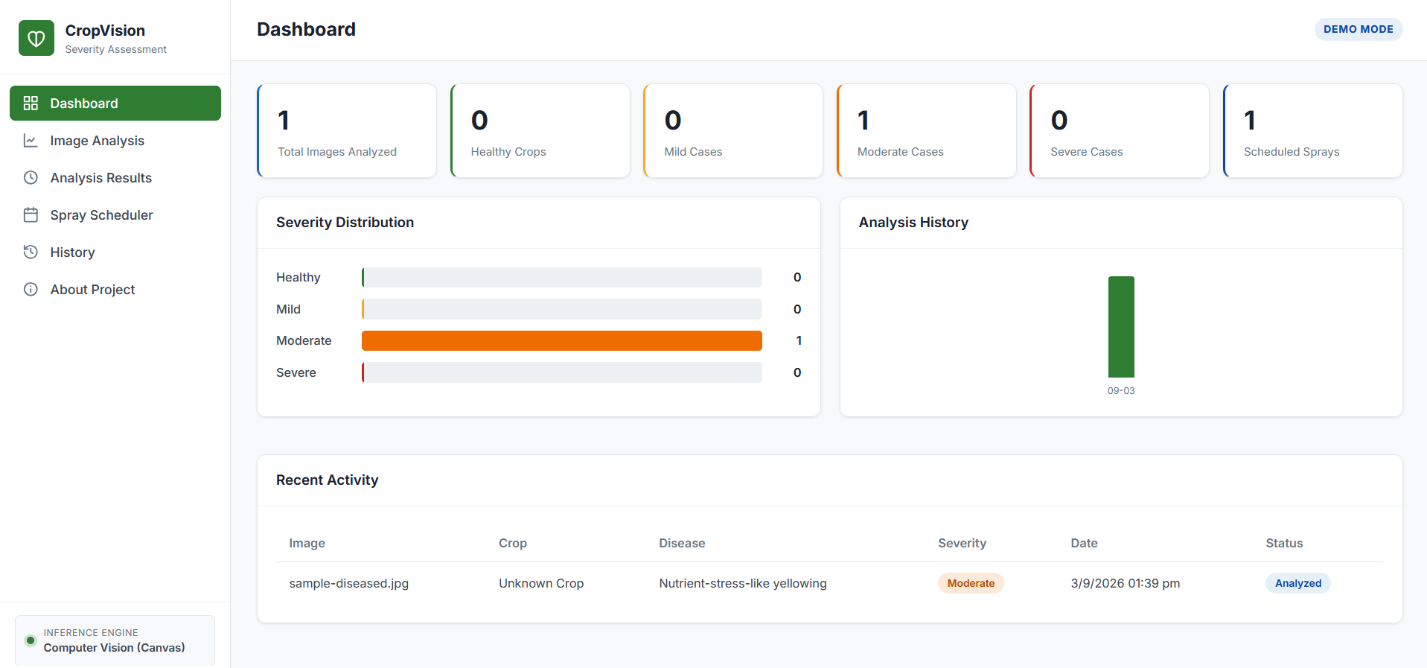 | 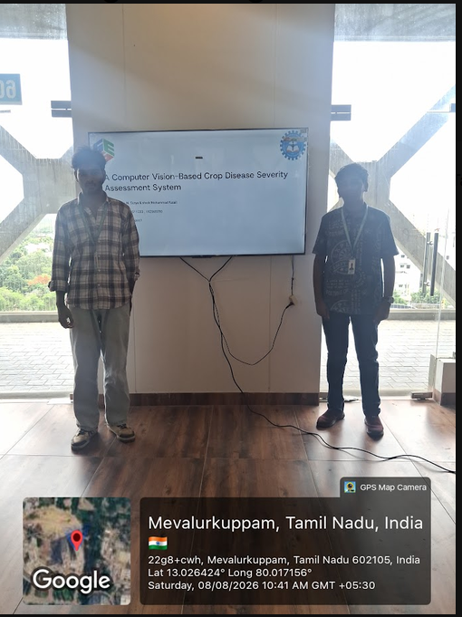
Project Description:
The Crop Disease Detection System is a software application developed to identify and assess diseases in crops using computer vision, image processing, and machine learning techniques. The system allows farmers or users to upload an image of a crop through a simple web interface. The uploaded image is processed using image processing techniques and analyzed by a machine learning model to identify the possible disease and determine its severity. The system provides the detected disease along with relevant information about the affected crop and suitable treatment recommendations.The application also includes a spray scheduling module that helps generate appropriate spray recommendations based on the detected disease and its severity. An image repository module is used to manage and access uploaded crop images, while the database stores important information such as crop details, detection results, disease information, and treatment records. The system follows a structured architecture with a frontend, Java backend, machine learning inference module, database, and supporting modules..

Student Signature Guide Signature

